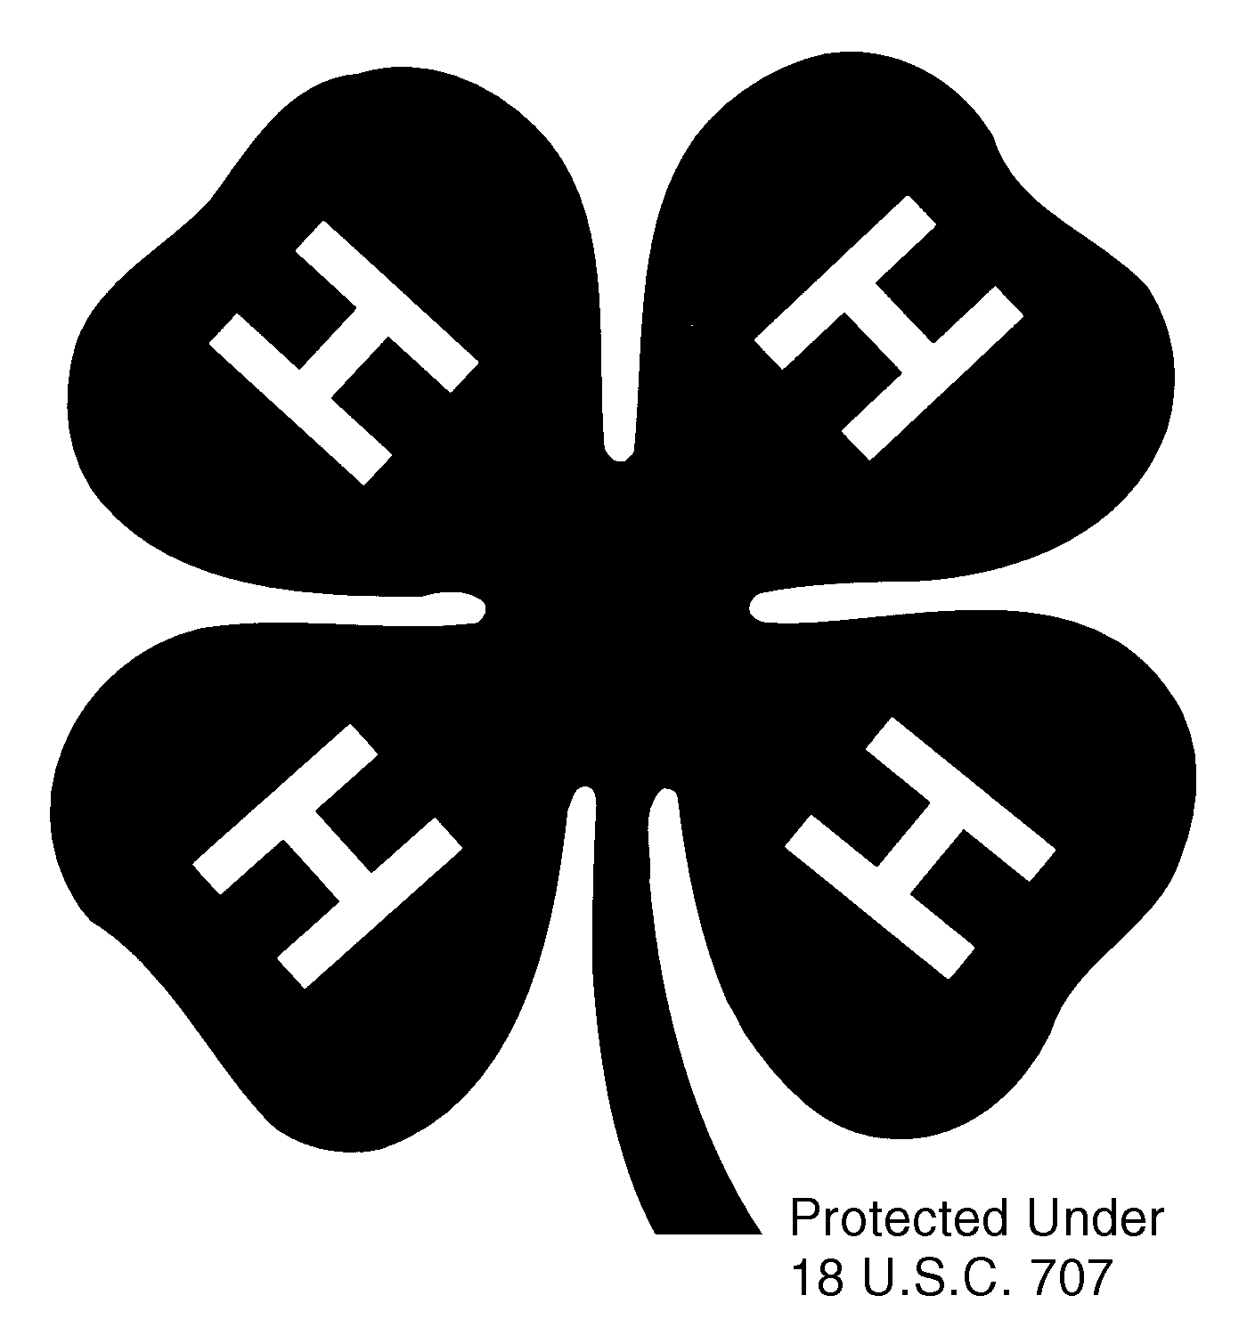
(year)

RACINE COUNTY 4-H

RECORD BOOK

YOUR PHOTO
HERE

NAME

ADDRESS

CITY STATE ZIP

PHONE

GRADE JUST COMPLETED AGE

PARENT/GUARDIAN NAME

CLUB NAME

The purpose of keeping Records is to help the 4-Her and their family measure the progress that is made. Record keeping is an opportunity for youth reflection and develops communication & organizational skills. Youth are encouraged to record experiences throughout the year. This helps youth see their accomplishments over time. ** Keep Record Book sheets for all your years in 4-H for future reference. **

/tmp/in/input.doc

INSTRUCTIONS FOR FILLING OUT YOUR RECORD BOOK SHEETS

Your permanent Record Book is the buff colored pages 3-8 and will not be replaced each year unless you request new sheets. However, the green pages will be replaced yearly as they contain only information for the current year. Please save these in a binder for your reference in seeing the accomplishments over time, applying for future awards and reflection.

Project Points - Page 3 - Fill in all the projects you are enrolled in and have achieved in for each year you have been in 4-H. You will receive up to 4 points per year on page 8 under Total Participation Points.

Participation Points - Pages 4-8.
You receive 1 point for each activity except if you see a (2) which indicates that you receive 2 points for that activity instead of just one.
For any activity marked with an asterisk (*), please go to page 9 or 10 and write a brief explanation of what you did. A summary or story of your 4-H year can be written on page 10 for two points under club level.
Participation points are accumulated, building on your past years' totals. (See page 8 bottom of the page.)

Total Participation Points for 4-H Activities - Page 8
Enter your totals from your project points, club, county and area for this year. Then total the Participation Points accumulated year after year.

Clover Points & Award - Page 11 When figuring if you have earned a Clover Award, you will count up the total number of Participation Points Accumulated (Page 8) from all the years combined and this year’s Clover Points. The requirements are listed on page 11 and more information is listed below.

Signatures Needed - Page 12. The member, parent/guardian and General Leader must sign.

Please note:
* A Jr. Leader is a youth who works with an adult in a project or activity. A Teen Leader works alone as the project or activity leader. A Teen Leader must work independently in order to receive points for this category.

*Attach a project sheet for each project you have achieved in this year.

RACINE COUNTY AWARD PROGRAM

The Awards Committee has divided the awards given in our county into 2 separate groups Participation & Leadership.

Participation Awards: are given as CLOVER AWARDS; bronze, silver, gold and emerald. These are determined by adding up the participating points and clover points in the back of this record book. These awards are open to any 4-H members who have the number of points required to win the clover award. A medal will be awarded from the county the first year youth achieve a Clover Award level and recognition will be given for those earned each year after at the Recognition Celebration in October. (See page 11 & 12.)

Leadership Awards include: the WI 4-H & Youth Conference, Citizenship-Washington Focus trip, National 4-H Congress & Conference trips, WI Federation of Cooperatives conference, Honor Court, Outstanding 4-H Teen in Racine County and the State 4-H Key Award. These awards will be determined by achieving a Clover Award level, which includes participation and clover points. Youth must also fill out a Trips & Awards Form and attend the Interview Process in the fall. Ask your club General Leader for more information.

PERMANENT RECORD BOOK

This permanent record book (buff colored sheets) is for you to keep track of your activities during the 4-H year from September 1 through August 31. On the Participation Pages 4-8, you should put points (1) or (2) in the proper column as you complete the activity. At the end of the year you add up all your points and YOU may receive a Clover Award. Be sure to include any youth leadership in a project or activity. YOU
MAY ONLY RECEIVE CREDIT FOR FOUR PROJECT POINTS PER YEAR ON PAGE 8. If you have any questions or need more space to list projects you can add an additional page by contacting your General Leader.

PROJECT POINTS
Please write each project once

List Year  Year in 4-H | ____  1 | ____  2 | ____  3 | ____  4 | ____  5 | ____  6 | ____  7 | ____  8 | ____  9 | ____  10 | ____  11 | ____  12
1.
2.
3.
4.
5.
6.
7.
8.
9.
10.
11.
12.

4-H CLUB MEETINGS ATTENDED

List Year  Year in 4-H | ____  1 | ____  2 | ____  3 | ____  4 | ____  5 | ____  6 | ____  7 | ____  8 | ____  9 | ____  10 | ____  11 | ____  12
Number of club meetings

Number of club meetings you attended

PARTICIPATION POINTS
CLUB LEVEL ACTIVITIES
List Year  Year in 4-H | ____  1 | ____  2 | ____  3 | ____  4 | ____  5 | ____  6 | ____  7 | ____  8 | ____  9 | ____  10 | ____  11 | ____  12
1.Gave leader record book on time
2.Completed project sheet for each project
3.Included 4-H newspaper clippings about you in it
4.Included your photo on front page
5.Attended 4-H club meetings
6.Attended club project meetings
7.*Member of club committee
8.*Chairperson of club committee
9.*Club officer
10.Helped with club project tour
11.Attended club picnic, tour or trip
12.*Helped with club community service
13.*Helped with club conservation project
14.*Helped with club recycling project
15.Helped with club June Dairy month project
16.*Helped with club safety project
17.*Helped with club recreation
18.Helped with club fund raiser
19.Helped with club Achievement Night
20.Helped start new club or new members start

Continue: Club Level Activities
List Year  Year in 4-H | ____  1 | ____  2 | ____  3 | ____  4 | ____  5 | ____  6 | ____  7 | ____  8 | ____  9 | ____  10 | ____  11 | ____  12
21.*Helped with community service not related to 4-H
22.*Jr. Leader in a project
23.*Teen Leader in a project (2)
24.*Jr. Leader in a 4-H activity
25.*Teen Leader in a 4-H activity (2)
26.Gave talk at club meeting
27.Gave demonstration at club meeting
28. Summary or story of your 4H year on Pg. 10 or attach. (2)
29.*Other 4-H Club Activity
30.*Other 4-H Club Activity
31.*Other 4-H Club Activity
32.*Other 4-H Club Activity
33.*Other 4-H Club
Activity
34.*Other 4-H Club
Activity
35.*Other 4-H Club
Activity
36. *Other 4-H Club
Activity
37.*Other 4-H Club
Activity
TOTAL Number of CLUB PARTICIPATION POINTS
COUNTY LEVEL ACTIVITIES
List Year  Year in 4-H | ____  1 | ____  2 | ____  3 | ____  4 | ____  5 | ____  6 | ____  7 | ____  8 | ____  9 | ____  10 | ____  11 | ____  12
1.Attended 4 county Jr. leader meetings
2.Helped at Jr. leader fund raiser-Call Booth or Twin Disc Picnic
3.Jr. leader committee chair (2)
4.*Jr. leader committee
5.Attended Night with the Stars
6.Attended Day Camp
7.Camp Counselor (2)
8.Attended 4-H Camp (2)
9.Demonstration or Speaking Contest (2)
10.Participated in Star Search (2)
11.Exhibited at County Fair (2)
12.Exhibited in Poster Contest
13.Monitor 4-H Building at Fair (2)
14.*Helped at Fair (2)
15.Attended County project meeting
16.Helped at County project meeting
17.Attended 4-H Achievement Night
18.MC at County Event

Continue: County Level Activities
List Year  Year in 4-H | ____  1 | ____  2 | ____  3 | ____  4 | ____  5 | ____  6 | ____  7 | ____  8 | ____  9 | ____  10 | ____  11 | ____  12
19.*Helped at County Event
20.Helped with 4-H promotion (2)
21.4-H Ambassador (2)
22.Participated in Kiwanis Award Contest
23.*Other 4-H County Activity
24.*Other 4-H County Activity
25.*Other 4-H County Activity
26.*Other 4-H County Activity
27.*Other 4-H County Activity
28.*Other 4-H
County Activity
29.*Other 4-H
County Activity
TOTAL COUNTY PARTICIPATION POINTS

DISTRICT, STATE AND NATIONAL 4-H ACTIVITIES (AREA)
1.Attended District meeting or workshop
2.Helped at District meeting or workshop (2)
3.Attended or Selected National Conference
4.Attended or Selected National Congress
5.WI 4-H & Youth Conference Delegate
6.Showcase Singers (2)

Continue: District, State and National 4-H Activities
Year  Year in 4-H | ____  1 | ____  2 | ____  3 | ____  4 | ____  5 | ____  6 | ____  7 | ____  8 | ____  9 | ____  10 | ____  11 | ____  12
7.*Participated at State Fair (2)
8.*Participated in other State 4-H event
9.*Participated in other State 4-H workshop (2)
10.Citizenship-
Washington Focus Delegate
11.*Participated in other National 4-H event
12.Participated in WI Fed. Of Cooperatives
13.*Other area 4-H activity
14.*Other area 4-H activity
15.*Other area 4-H activity
16.*Other area 4-H activity
TOTAL AREA PARTICIPATION POINTS

TOTAL PARTICIPATION POINTS FOR 4-H ACTIVITIES
No more than (4) PROJECT points per year
CLUB
Participation Points
COUNTY Participation Points
AREA
Participation Points
TOTAL for this Year
TOTAL
Accumulated Points

SAVE THESE SHEETS FOR FUTURE REFERENCE year_________
Please give a brief description of any numbers marked with an *.

Club section

*7

*8

*9

*12

*13

*14

*16

*17

*21

*22

*23

*24

*25

*29

*30

*31

*32

*33

*34

*35

*36

*37
County section
*4

*14

*19

*23

*24

*25

*26

*27

*28

*29
Continued on Back

Area section

*7

*8

*9

*11

*13

*14

*15

*16

SUMMARY OR STORY OF YOUR 4-H YEAR. ( You may attach a separate sheet.)

CLOVER POINTS for CLOVER AWARDS Year

Please fill in one point (1) in each row for any activity that you have participated in this year. You can only receive 1 point in each row. Enter the total at the bottom. Please put totals on next page if you qualify for a Clover Award.

Activity Done This Year | Brief Description/Explanation | Points
1.*Attended 3/4 of club meetings (See *1 below)
2.Attended 3/4 of project meetings
3. Attended 4 or more county Jr. Leader meetings
4.Junior or Teen Leader in a project
5.Participate OR exhibited in a
District or State 4-H event
6.**Did a demonstration at a 4-H event (See **6 below)
7.Member of a club committee
(name: )
8. Member of a county committee
(name: )
9.Chairperson or Co-chairperson of a club committee
(what: )
10. Chairperson or Co-chairperson of a county committee
(what: )
11.Held a club office this year
12.Held a county office this year
13. ***Participated in a county event
(name: ) (See ***13 below)
14.Sold pizza items or donated money for county fund raiser
15. Worked at the Jr. Leader’s Call Booth at the Fair
or worked at the Twin Disc Picnic fundraiser
16. County 4-H Ambassador (must attend a minimum of three (3) Ambassador functions) (See ****16 below)
TOTAL CLOVER POINTS THIS YEAR
Please note the following special instructions:
*1. If your Club held 12 meetings, you must have attended 9, if they had 10 or 11, you must have attended 8 and if they had 9 you must have attended 6. List these numbers, example: 12 of 12 attended.
**6. A demonstration can be done at a Club or Project Meeting, Communication & Arts Festival, the Fair or any other 4-H event.
***13. This includes for example; the County Archery Fun Shoot, Cloverbud/Explorer Fun day, Clothing Revue, Dog Fun Show, Small Pets Fun Match, Foods Workshop, Foods Festival, Poster Contest, Communication & Arts Festival, Show Case Stage at Fair, Night with the Stars, Star Search, Holiday Ball, Summer 4-H Camp, Wustum Museum Arts Workshop, Dairy & Meat judging or any other county project clinics/workshops. This does NOT include county project events meetings such as: County Fair Showmanship, or County Fair, or mandatory events such as MAQA and any Pre-fair Judging events. Updated 10/12
****16. This includes for example participating in; Parades, Tri-County Event, County Fair, working picnics, speaking to clubs, presentations to schools, groups, county officials etc. as a representative of Racine County 4-H as an Ambassadors at these events.
CLOVER AWARD REQUIREMENTS
To earn a Clover Award, you must have the following number of points. See page 2 for more information.
Bronze award requires: 6 Clover Points & a total of 45 accumulated Participation Points
Silver award requires: 8 Clover Points & a total of 95 accumulated Participation Points
Gold award requires: 10 Clover Points & a total of 150 accumulated Participation Points
Emerald award requires: 12 Clover Points & a total of 210 accumulated Participation Points

CLOVER AWARD EARNED

Please indicate your total: Participation Points accumulated:
Clover Points earned:

CLOVER AWARD EARNED THIS YEAR: YEAR

Please indicate the year you received the following awards. Clover Awards:
Bronze Silver

Gold Emerald

Leadership Awards: Please note the order listed below may have changed.

WI 4-H & Youth Conference

Wisconsin Federation of Cooperatives

Citizenship-Washington Focus

Honor Court Outstanding 4-H Teen

WI 4-H Key Award Kiwanis Award

County Project Award Farm Bureau Award

National 4-H Congress National 4-H Conference

National Dairy Conference

Please sign and have your parent/guardian and your General Leader sign this page below.
If you fail to complete this, you will be disqualified from any awards.

_______________________________ ______________________________
MEMBER (Signature) PARENT/GUARDIAN (Signature)

______________________________ *Attention Seniors:
GENERAL LEADER (Signature) I plan to graduate from 4-H this Year Yes No

/tmp/in/input.doc

